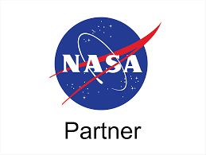

Request for Proposals # 1
TCU Building Bridges Grant Program

A Science, Technology, Engineering & Math (STEM) grant-funding opportunity developed in partnership with the American Indian Higher Education Consortium (AIHEC) and the National Aeronautics and Space Administration (NASA)

PROJECT TITLE: TCU Building Bridges Grant Program
PROPOSAL DUE DATE: 11:59 PM Eastern Time (ET) November 20, 2026
FUNDING AMOUNT: Multiple awards of up to $75,000 are available
ELIGIBILITY: Funds are available to faculty-led teams from all accredited Tribal Colleges & Universities. Multiple proposals from the same institution are permitted; however, each proposal shall have a unique Principal Investigator (PI) and be a separate, stand-alone, and complete document to enable NASA to properly evaluate it.
ESTIMATED CONTRACT PERIOD: January 4, 2027, through January 4, 2029.

SUBMIT PROPOSALS TO: Buildingbridges@aihec.org

All communications concerning this Request for Proposals (RFP) must be directed only to the RFP Coordinator via email. Any other communication will be considered unofficial and non-binding. Applicants are to rely on written statements issued by the RFP Coordinator. This RFP is available on the AIHEC website at https://www.aihec.org/stem/tcu-buillding-bridges/. RFP amendments and/or Applicant questions and AIHEC answers will be posted to the AIHEC website.

TCU Building Bridges Grant Program – Cycle 1

Contents
Introduction 1
NASA & AIHEC’s Programmatic Goals 1
Application Cycle & Timeline 3
Proposal Preparation & Submission 4
Proposal Scoring & Selection Process 7

– ii –

Introduction
The American Indian Higher Education Consortium (AIHEC), in partnership with The National Aeronautics and Space Administration (NASA), is excited to announce The TCU Building Bridges Grant Program, a Science, Technology, Engineering & Math (STEM) grant-funding opportunity that is being made available exclusively to Tribal Colleges and Universities (TCUs). Specifically, grants of up to $75,000 will be awarded to TCUs that prepare and respond to this call for proposals.
It is NASA’s goal that the NASA AIHEC Building Bridges program will enhance the ability of TCUs to provide high-quality STEM education programs, participate in collaborative STEM research initiatives, and ensure the inclusion of American Indians and Alaska Natives in a well-prepared NASA STEM workforce.

NASA & AIHEC’s Programmatic Goals
The NASA AIHEC Building Bridges Program seeks STEM program enrichment projects such as course and curriculum development, research activities, and student engagement with the overall goal of broadening TCU students’ participation in STEM programs and careers. NASA AIHEC Building Bridges Program funded projects are expected to address at least two of the three program goals:
- Increase the number of TCU students engaging in STEM research and education activities. (Examples: internships, externships, Experiential Learning Opportunities (ELOs), Research Experiences for Undergraduates (REUs))
- Increase the enrollment of TCU students in STEM degree programs and pursuing STEM career pathways.
- Strengthen the capacity of the TCUs to deliver STEM courses, degrees and curriculum.
In addition to addressing the goals stated above, each proposal must demonstrate how they will align to at least one of the following NASA Office of STEM Engagement Performance Goals below:
- Performance Goal 1: Prepare students for the aerospace workforce through investments to strengthen research capacity and align with NASA missions and needs
- Performance Goal 2: Prepare students for the aerospace workforce through work-based learning and experiential opportunities that build technical skills
- Performance Goal 3: Prepare students of the aerospace workforce by expanding reach through career connected-learning opportunities

Priority areas for support will include, but are not necessarily limited to:
- Research experiences for undergraduates (REUs);
- STEM program instrumentation/equipment acquisitions;
- Course and curriculum enhancements (new courses, delivery support technologies)
- Professional development for TCU faculty, undergraduate, and graduate students, including conferences and workshops;
- In-person NASA Internships for TCU students, which must be funded at the same level of set NASA Intern cost amounts, as shown in the tables below:
Summer Intern Costs | Stipend
Undergraduate Full-time | $8,200
Graduate Full-time | $9,900
Fall/Spring Intern Costs | Stipend
Undergraduate Full-time | $13,120
Graduate Full-time | $15,840
Undergraduate Part-time | $6,560
Graduate Part-time | $7,920

NASA internships are In-Person at a NASA Center.

Intern stipends must not be below the figures in these tables. These are the official NASA intern costs set by the agency.

Please Note: proposing institutions can budget additional costs to support interns such as travel and housing stipends
Summer Internships: 10 weeks in duration Spring/Fall Internships: 16 weeks in duration

- NASA Internship support could also include budget for the following:
  - support for travel to and from NASA center for intern
  - additional housing stipend
  - faculty mentor stipend
- Additional opportunities to increase TCU students’ STEM participation, primarily at the undergraduate level, including participation in STEM enrichment activities, conferences, workshops and competitions.
If awarded, grantees will also receive ongoing technical assistance from both AIHEC as well as NASA to support program success.

Application Cycle & Timeline
To guide the application process and to understand the campus experiences of TCU staff and further professional learning for applicants, four webinars and workshops will be held to provide guidance, highlight best practices, offer resources, outline expectations, and address questions. TCU faculty and staff who are interested but are not ready to submit a project are encouraged to attend workshops and learn more about the program, then submit an application for a future cycle.

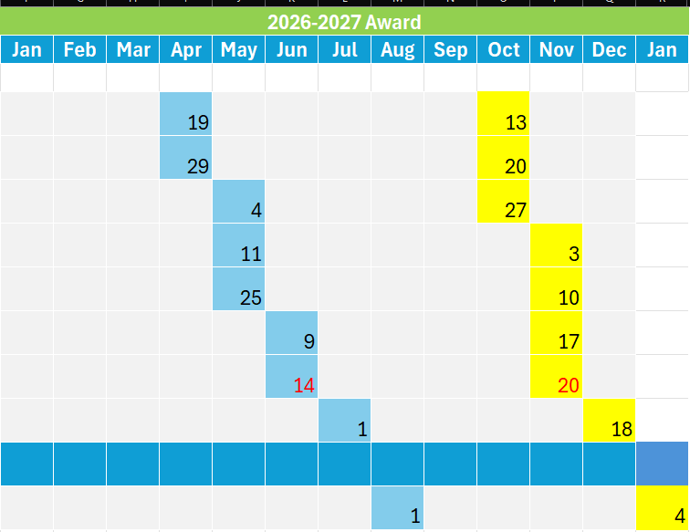
Milestones

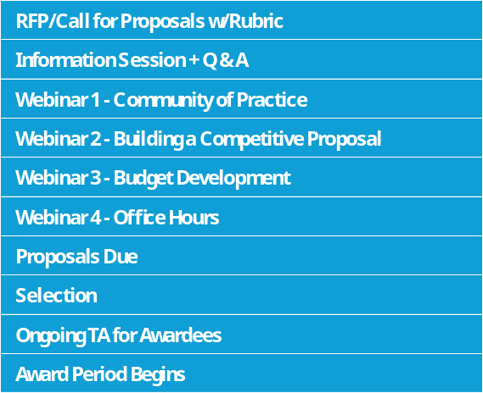

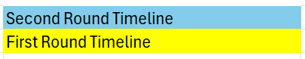

Proposal Preparation & Submission
The proposal narrative should be organized in a way that provides a detailed description of the proposed project. The narrative should be no more than 10 pages in length and should contain the following elements:
Section 1: Project Title and abstract (1 page) – Please include a title for your project and a short summary abstract- up to 250 words- describing your project in brief. In your project summary, please include:
- Institution – The TCU(s) that will be carrying out the project
- Principal Investigator(s) – The name and title of the faculty/staff member(s) leading the project.
- Co-Principal Investigator(s) - The name and title of the faculty/staff member(s) co-leading the project. (optional)
- Collaborators and Partner Institution(s) - The names and titles of individual collaborators or partners and/or the names of collaborating/partnering institutions and organizations. (optional)
- Project Duration – The estimated duration of your project.
TCU faculty who completed a pre-application can use the same abstract as the one written for the pre-application.

Section 2: Engaging Community & Building Capacity (1 – 3 pages)
- Learning: outcomes for community or TCU students – Discuss how this project will impact the lead institution and community. For example, if students are working on the project, what knowledge or skills will they obtain? How many students will the project support and impact? Will they receive course credit? How will this project support their successful entry into a STEM career in the future?
- Alignment: contribution to larger TCU or department mission and goals
- Clearly demonstrate how this project will address two of the three stated NASA AIHEC Building Bridges programmatic goals.
- Clearly demonstrate how this project advances existing goals for STEM within a department, division, team, office within the lead institution.
- The proposals should also demonstrate alignment to at least one of the stated NASA Office of STEM Engagement Performance Goals.

- Project staffing and biographical sketch – Please provide a minimum of one paragraph biography of each project staff member, including the names, anticipated project roles, and professional titles (such as faculty member, student, coordinator, analyst, etc.). Include any information related to each project member’s capacity to perform their role, including relevant experience, certifications, or coursework. The lead PI will need to also submit a current and robust Curriculum Vitae (CV).

Section 3: Creating the Story (maximum of 3 pages)
- Landscape Discussion/Statement of Purpose – Discuss the current state of the field in relationship to your area of interest, including what needs may exist in the field or areas that are underexplored. Describe the overarching goals of the project, specifically addressing the question: What learning, community, institutional, or research gaps in the STEM field does this project seek to fill?
- Project Scope – Provide a detailed summary of the project plan, including key milestones, research questions and methods as applicable, outputs and deliverables. If this project is meant to continue larger ongoing or in-progress work, please describe efforts that have been completed to date, and what aspects of the work this project hopes to continue.

Section 4: Building the Scaffolding
- Budget narrative – Write a budget justification narrative that clearly describes anticipated expenditures and how they are necessary for the project. For each budget category, provide appropriate details, taking care to be as specific as possible. Be sure to address any vague
items such as ‘supplies’. This will precede the budget table.
- Budget table - Applicants should provide a concise list of anticipated expenditures. NASA Bridges funds may be used for the support of the following:
- TCU students, faculty, and staff - proposal budgets should clearly indicate key personnel roles and responsibilities
- Subject matter expert consultants
- Research-related equipment, travel, and materials
- Professional development program registrations and associated travel costs
- The budget must clearly include information documenting approved overhead/general and administrative (G&A) rate.
- NASA and AIHEC will provide a sample budget template. Applicants will not lose points for using their own template, as long as it is clear and concise.
In the table, be sure to include the item, a brief description if necessary, and the anticipated total cost of the item or service. For staff and personnel time, include both the total amount as well as a per diem or hourly rate.

Budget Guidelines and Funding Restrictions
- Funding for the PI salary must not exceed 15% of the proposer’s total budget.
- A maximum of 20 percent of the total budget may be used for infrastructure (equipment and laboratory facilities).
- A maximum of 15 percent of the total budget may be used for acquiring direct NASA services related to the conduct of research (i.e., cost for use of NASA unique facilities, etc.).
- A maximum of five (5) percent of the total budget may be distributed to NASA Centers that are partnering with institutions.
  - These funds may not be used for NASA civil servant salaries or travel.
- The lead TCU shall retain and utilize100 percent of the total budget. No subawards will be allowable under these grants.

Section 5: Planning, Implementing & Celebrating (maximum of 3 pages)
- Implementation timeline – Provide a detailed timeline for the project, including anticipated key dates for milestones, deliverables, and other important project tasks. The timeline can be written or represented visually.
- Storytelling – Discuss how the project will deliver any final products such as reports, media, or presentations, as well as how such deliverables may be shared with other TCUs, the broader research community, or general public. If no tangible products are being developed, video or audio logs and diaries are acceptable. In addition, be sure to include clear metrics of success for the project along with a simple evaluation plan. It is important to be able to demonstrate evidence of success in reaching stated goals.

Proposal Scoring & Selection Process
Proposals will be evaluated by a merit review panel composed of the proposers’ professional peers (government and non-government), including STEM education and evaluation experts, who have been screened in advance for any conflicts of interest. An award decision will be made 4 weeks after the application deadline. Proposals must be submitted by November 20, 2026, to be considered for this cycle of awards.
Selection criteria include:
- Clearly addresses two of the three NASA AIHEC Bridges Programmatic Goals and alignment to one NASA Office of STEM Engagement Performance goal;
- Degree to which the project is part of the TCU’s overall STEM plan or encourages the development of such plan;
- Demonstrates an achievable timeline for project activities over the period of performance, including measurable metrics of success;
- Describes the feasibility of the project: appropriateness of projects or technologies proposed;
- Clearly identifies all members of the partnership and how each member will contribute towards the research efforts of the proposed activity;
- Describes student engagement and an overall goal to broaden participation in STEM;
- Aligns with budget guidelines and requirements;
- Describes how the proposed budget is allocable, allowable, and reasonable.
A sample rubric will be shared with prospective applicants ahead of the deadline.

